***Node.js***

***Day-3:***

1. What is event emitter NodeJS?

* The EventEmitter is a module that facilitates communication/interaction between objects in Node.

1. How to read and write files with NodeJS?

* **Synchronous method to read the file:**

To read the file in synchronous mode we use a method in fs module which is **readFileSync()**. It takes two parameters first is the file name with complete path and the second parameter is the character encoding which is generally ‘utf-8’.

* **Synchronous method to writing into a file:**

To write the file in a synchronous mode we use a method in fs module which is **writeFileSync()**. It takes two parameters first is the file name with the complete path in which content is to be written and the second parameter is the data to be written in the file.

* **Asynchronous method to read and write from/into a file:**

To read/write the file in an asynchronous mode in fs module we use **readFile()** and **writeFile()** methods.

* The **fs.readFile()** takes three parameters first is the file name with the complete path, the second parameter takes the character encoding which is generally ‘utf-8’ and the third parameter is the callback function (which is fired after reading complete file) with two parameters, one is the error in case error occurred while reading file and second is the data that we retrieve after reading the file.
* the **fs.writeFile()** also takes three parameters, file name with its complete path, the second parameter is the data to be written in file and the third is a callback function which fires in case an error occurs while writing file.
* **Note:** An Asynchronous method first completes the task (reading the file) and then fires the callback function.

1. How to create and remove directories in NodeJS?

* **Creating Directories:**

To create a directory synchronously, the **fs.mkdirSync()** method can be used.

To create a directory asynchronously, the **fs.mkdir ()** method can be used.

* **Deleting Directories:**

To delete a directory synchronously, the **fs.rmdirSync()** method can be used.

To delete a directory asynchronously, the **fs.rmdir()** method can be used.

1. How to create a server in NodeJS?

* The HTTP module create an HTTP server that listens to server ports and gives a response back to the client.
* The **createServer()** method is used to create an HTTP server.

1. What is a Buffer?

* Temporary storage spot for a chunk of data that is being transferred from one place to another.
* The buffer is filled with data, then passed along.
* Transfer small chunks of data at a time.

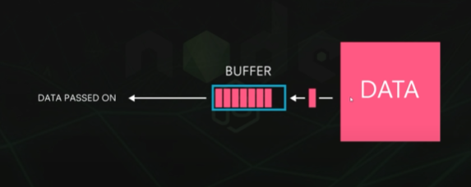

1. What are Streams?

* Streams are objects that read data from a source or write data to a destination in continuous way.
* We can create streams in Node.js to transfer data.
* Increase performance.

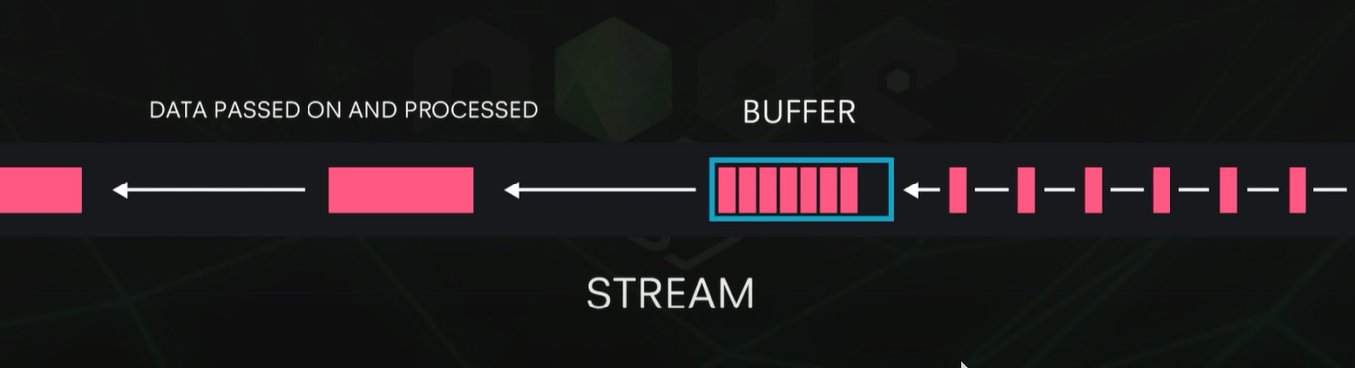

* **Types of Streams:**

1. **Writable streams -** allow node js to write data to a stream.
2. **Readable streams -** allow node js to read data from a stream.
3. **Duplex -** can read and write to a stream.